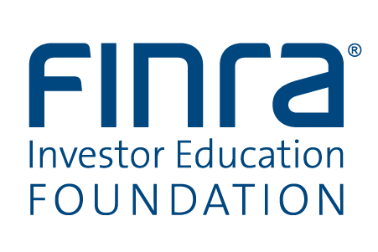

Project Concept

FINRA Foundation Grant Program

Please refer to the Grant Guidelines and Grant Program Overview prior to submitting this Project Concept.

Before completing this form, please save it to your computer’s hard drive. Submit the completed form as an e-mail attachment to finrafoundation@finra.org. Use as the subject line: Project Concept from (insert the name of the applicant organization).

Contact Information

Information about the 501(c)(3) Organization
Name of Project Principal* | Full name of 501(c)(3) organization (or college/university)
Title or position of Project Principal | Name and telephone number of contact if different from Project Principal
Address | Address
Telephone Area Code & Number Ext. | Web address:
E-mail address | Nine-digit Federal Identification Number

*The Project Principal is the individual with primary responsibility for the project, if funding is approved, on behalf of the 501(c)(3) organization.

Project Title:

Grant Amount: Please provide a preliminary estimate of the total amount of the grant request for this project. Indirect costs or overhead must not exceed 10% of direct costs.

Duration: Please indicate the number of months you anticipate will be needed to conduct the project.

Type of Project: Mark (x) one of the following: ___ Education ___ Research
Goals: Provide one to two sentence summaries of the primary goals of the project.

Describe the target audience to be served by this project. Do not exceed the space provided.
Describe any partnerships involved in the proposed project, and explain how the partnerships strengthen the project. Do not exceed the space provided.

Project Description: Summarize the proposed project. Include the major project elements and deliverables. Do not exceed the space provided.

Marketing and Distribution are of critical importance to successful FINRA Foundation grant projects. Describe fully your ability to reach and actively engage the target audience you described on page 1. Do not exceed the space provided.

If there is any additional information you feel the FINRA Foundation should be aware of concerning the importance of this project, please note it in the space provided. (As an example, you may refer the FINRA Foundation to a Web link where credentials of the Project Principal or other information can be located.)

By submitting this application, the grant applicant represents that the proposed Project Principal has not been convicted or found in violation of any state or federal securities laws, has not been enjoined or sanctioned by any regulatory authority for those types of violations, and is not named as a defendant in any pending federal action alleging securities laws violations.

Please submit this form, as an e-mail attachment, to finrafoundation@finra.org.
Use as the subject line: Project Concept from (insert the name of the applicant organization).

For additional information, please refer to the Foundation Grant Guidelines
and program information at www.finrafoundation.org.

